15.42: The condition that 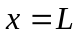 is a node becomes 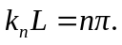 The wave number and wavelength are related by 